**DIGITAL NURTURE 4.0 DEEP SKILLING JAVA FSE-WEEK1**

**NAME: SIVITHA GUNASEKARAN**

**SUPERSET ID: 6413354**

**WEEK 1: DESIGN PATTERNS AND PRINCIPLES**

**Exercise 7: Implementing the Observer Pattern**

**Scenario:**

You are developing a stock market monitoring application where multiple clients need to be notified whenever stock prices change. Use the Observer Pattern to achieve this.

**Steps:**

1. **Create a New Java Project:**
   * Create a new Java project named **ObserverPatternExample**.
2. **Define Subject Interface:**
   * Create an interface **Stock** with methods to **register**, **deregister**, and **notify** observers.
3. **Implement Concrete Subject:**
   * Create a class **StockMarket** that implements **Stock** and maintains a list of observers.
4. **Define Observer Interface:**
   * Create an interface Observer with a method **update().**
5. **Implement Concrete Observers:**
   * Create classes **MobileApp**, **WebApp** that implement Observer.
6. **Test the Observer Implementation:**
   * Create a test class to demonstrate the registration and notification of observers.

**CODE SAMPLES:**

import java.util.*;

interface Observer {

void update(double price);

}

interface Stock {

void register(Observer o);

void deregister(Observer o);

void notifyObservers();

}

class StockMarket implements Stock {

private List<Observer> observers = new ArrayList<>();

private double stockPrice;

public void register(Observer o) {

observers.add(o);

}

public void deregister(Observer o) {

observers.remove(o);

}

public void notifyObservers() {

for (Observer o : observers) {

o.update(stockPrice);

}

}

public void setPrice(double price) {

this.stockPrice = price;

notifyObservers();

}

}

class MobileApp implements Observer {

public void update(double price) {

System.out.println("Mobile App: Stock price is ₹" + price);

}

}

class WebApp implements Observer {

public void update(double price) {

System.out.println("Web App: Stock price is ₹" + price);

}

}

public class ObserverPatternExample {

public static void main(String[] args) {

StockMarket market = new StockMarket();

Observer mobile = new MobileApp();

Observer web = new WebApp();

market.register(mobile);

market.register(web);

market.setPrice(100.0);

market.setPrice(125.5);

}

}

**OUTPUT:**

**Mobile App: Stock price is ₹100.0**

**Web App: Stock price is ₹100.0**

**Mobile App: Stock price is ₹125.5**

**Web App: Stock price is ₹125.5**

**MY SCREENSHOT PROOFS:**

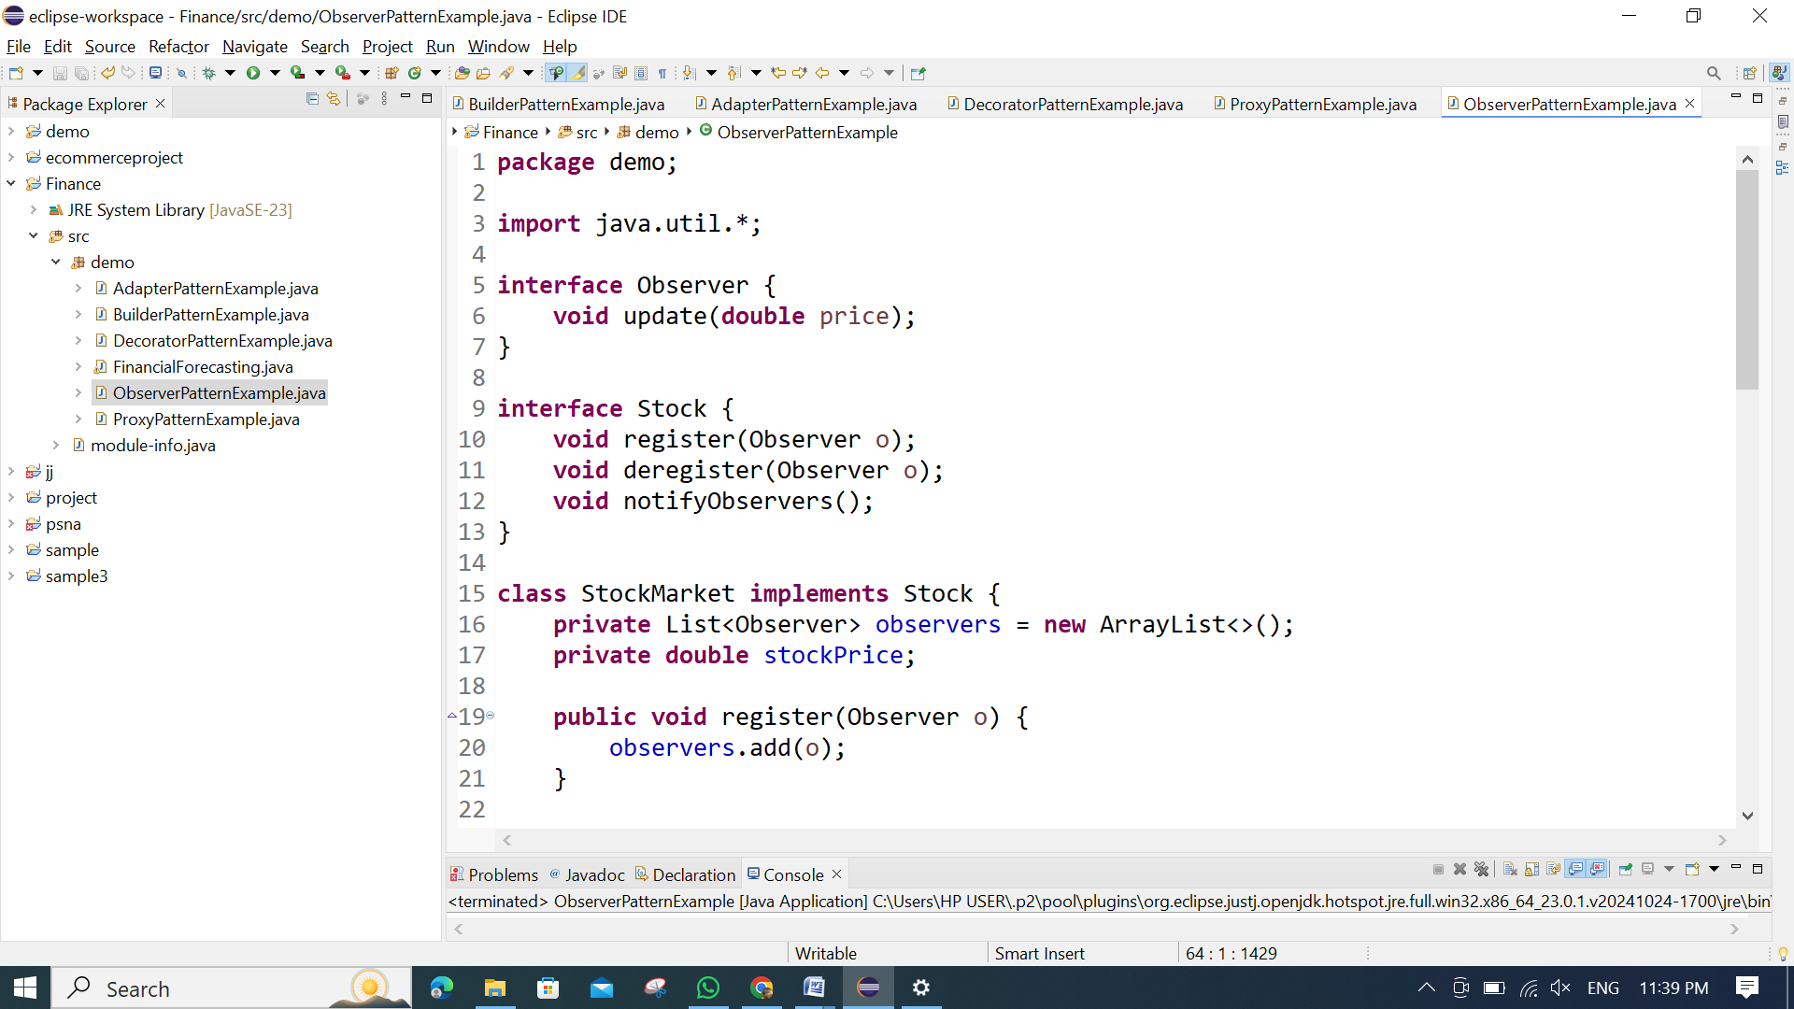 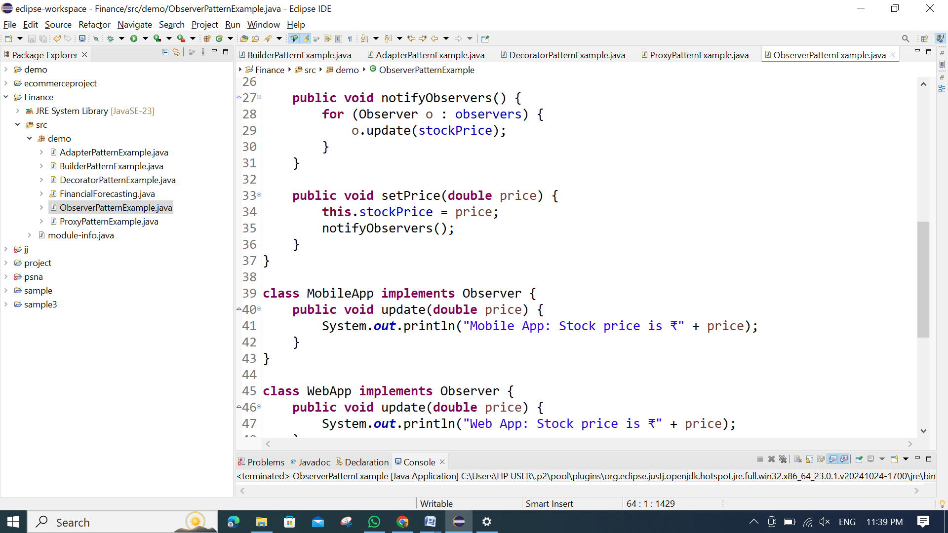 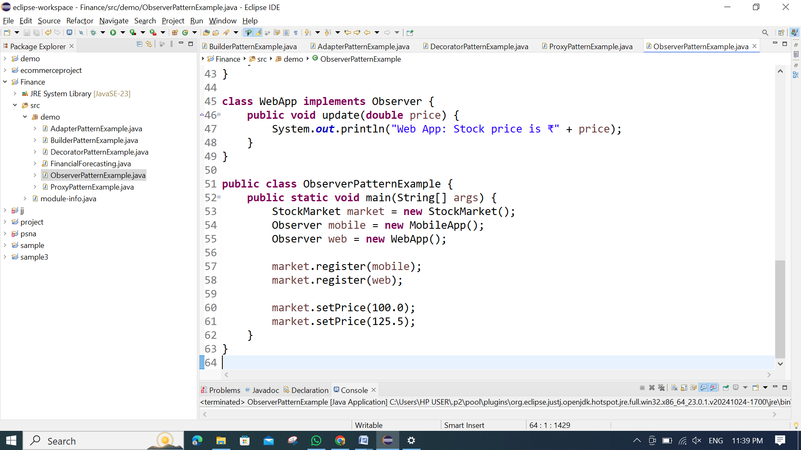

**OUTPUT:**

